Pharmacy Stock & Expiry Management System
Business Analysis Portfolio Project
Prepared by: Britney Senaratne

Strategic analysis and system design for a Pharmacy Stock & Expiry Management System. This project demonstrates end to end requirement engineering, from problem identification to UI wireframing

Executive Summary
The Pharmacy Stock & Expiry Management System project focuses on addressing the operational inefficiencies prevalent in small scale pharmacies, specifically regarding inventory tracking and medication expiry management.
Through this analysis, a structured solution was developed to automate stock updates, generate real time low stock alerts, and implement an automated expiry notification system. The project demonstrates the application of industry standard business analysis techniques, including requirement engineering, process modeling, and UI wireframing. By bridging the gap between manual pharmacy operations and a technology driven framework, this project aims to minimize financial losses and enhance overall operational efficiency.

1. Project Overview
Problem Statement: Small scale pharmacies often rely on manual stock management, leading to significant operational challenges. Pharmacists struggle to track medication expiry dates, resulting in wasted inventory and financial loss. Furthermore, the lack of real time inventory tracking often leads to stockouts, directly affecting customer service.
Scope of the Project: This project focuses primarily on optimizing the Inventory Management and Expiry Tracking processes. Future modules such as advanced billing and payroll are excluded from this phase.

2. Functional Requirements
Inventory Management: Add, update, and categorize new medicine stock.
Expiry Alert System: Automated notifications for medicines expiring within 30 days.
Low Stock Alert: Real-time alerts when inventory falls below a set threshold.
Sales Recording: Automated invoice generation and inventory deduction.
Search Functionality: Instant search by name or category.

ID | User Story | Acceptance Criteria
US01 | As a Pharmacist, I want to add new medicines to the system, so that I can maintain an accurate inventory record. | Medicine name, price, and expiry date must be correctly saved in the database upon entry.
US02 | As a Pharmacist, I want to receive alerts for expiring medicines, so that I can remove them from the shelf. | Medicines expiring within 30 days must be highlighted in red on the dashboard.
US03 | As a Pharmacist, I want to be notified of low stock, so that I can reorder items before they run out. | An alert must trigger when the stock count drops below the threshold limit.
US04 | As a Pharmacist, I want to generate a sales invoice, so that I can provide customers with a record of their purchase. | Selecting medicines and clicking "Generate Bill" must produce a downloadable PDF invoice.
US05 | As a Pharmacist, I want to search for medicines by name, so that I can quickly serve customers. | Typing the first few letters of a medicine name must display matching results instantly.

3. PROCESS FLOW CHART

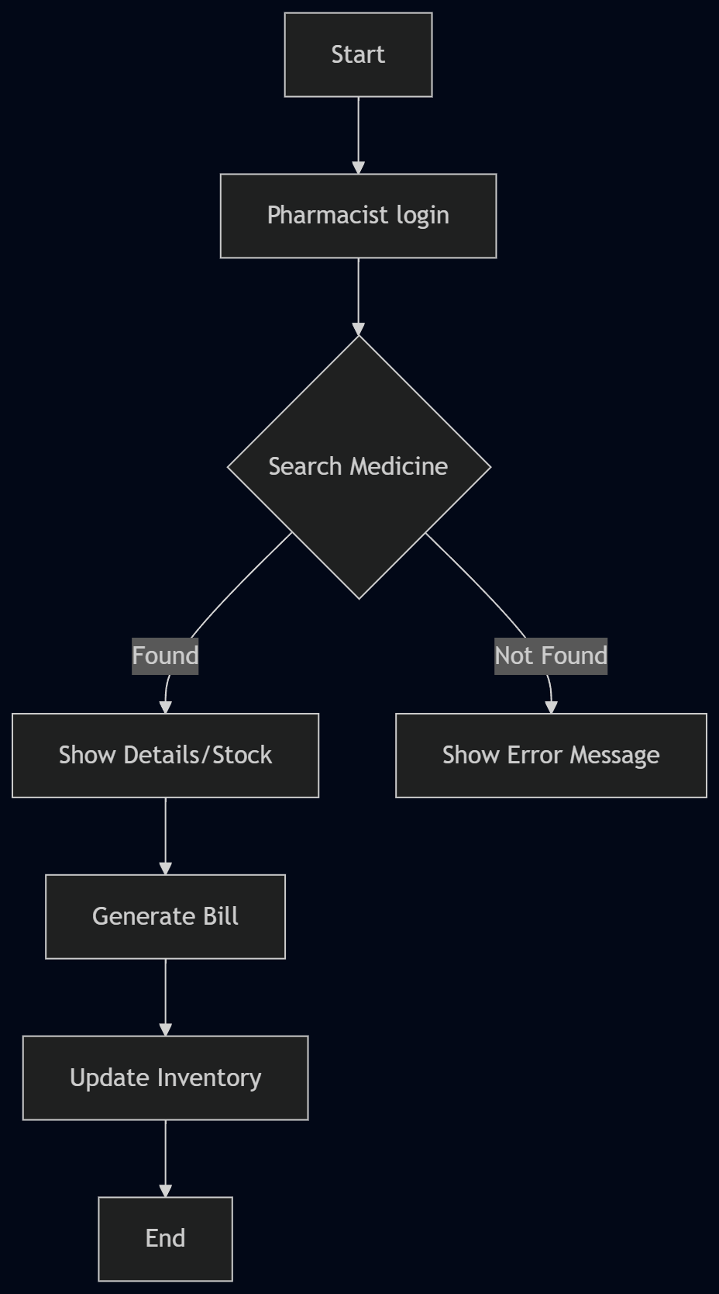

4. UI WIRE FRAME

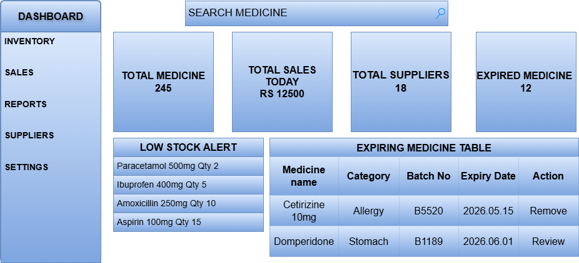
Figure 02: Pharmacy Stock & Expiry Management System - Wireframe Layout

This wireframe illustrates the dashboard layout for the pharmacy system, focusing on critical modules such as real time Low Stock Alerts, Expiry Tracking, and quick Search accessibility

5.TOOLS USED
- Documentation & Requirement Analysis: Microsoft Word
- Process Modeling: Mermaid.js
- UI/UX Wireframing: Draw.io
- AI-Assisted Analysis: Gemini

6. Conclusion
This project successfully addressed the operational challenges in manual pharmacy inventory management through a structured Business Analysis approach. By defining precise functional requirements, visualizing the system logic through flowcharts, and designing an intuitive dashboard wireframe, this project provided a clear blueprint for an automated solution.
Beyond the technical deliverables, this project served as a practical application of core BA methodologies, reinforcing the importance of user centric design and systematic requirement engineering. Ultimately, this framework provides a foundation that can be further scaled to include advanced features, effectively bridging the gap between pharmacy business needs and digital efficiency.

